Welcome to 26751 Mt Nebo Road
Onancock, VA 23417

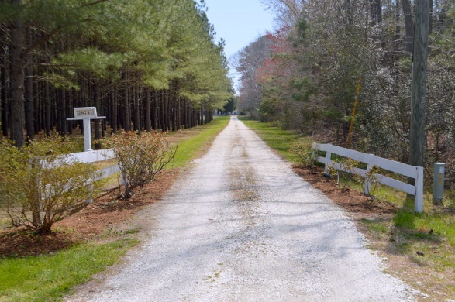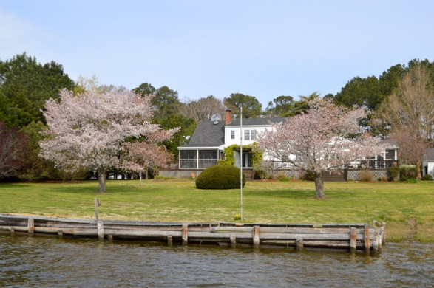
Waterfront Retreat just 9 minutes by car from Onancock and the same by boat to the bay. 20 acres of privacy on Pungoteague Creek. Dock has a 4 ton lift, water is 2 to 4 ft-- always enough for owners 24” Grady White. 350 ft. of waterfront then the marsh winds around. Open plan gourmet kitchen/great room is the center of the home with soaring ceilings and fireplace. The living room has fireplace too of course. And lots of great architectural details. 1st floor master and bath and 4 more rooms upstairs. 2 screened porches. Expansive deck. Separate office or studio space attached to garage. Wonderful plantings and flowing trees. Bring your horses. Two tax maps--waterfront home is on 7.2 acres, waterfront land is 12.8. Build a family compound! This is a very special property. Come explore!

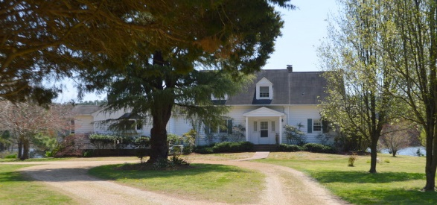

Special Features Include:

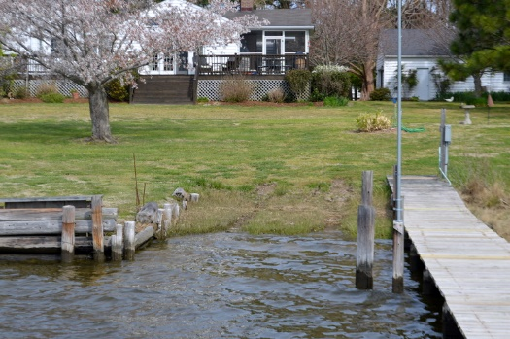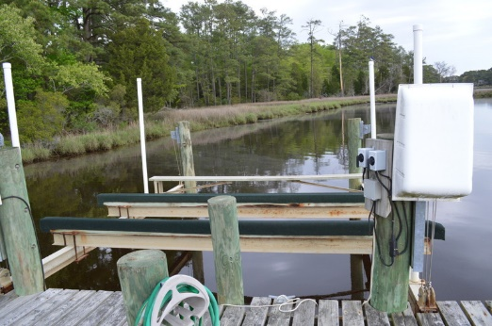
- Dock has water, power, a 4 ton boat lift and a boat ramp. Wow, a boat ramp.
It is 2.5 miles to bay, takes the owner 8-9 minutes in his 24 foot Grady White
- In addition to the house there is a separate office attached to the garage—or turn it into a studio or bunk house for the grandkids.
- Kitchen and great room has fireplace and heating zone of its own
- Full basements are very rare on the shore and this one has a vintage stove, fridge and freezer. Used by owners when they have 19 relatives for Thanksgiving. Yours if you want them.

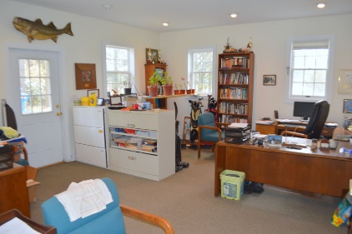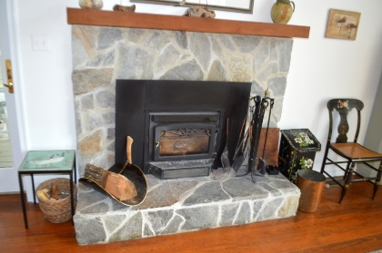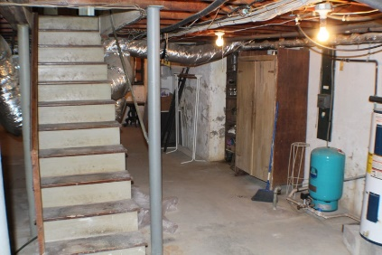

Second Lot:
12.8 acres of waterfront on separate tax map
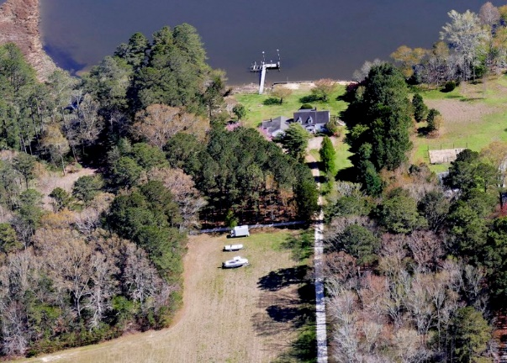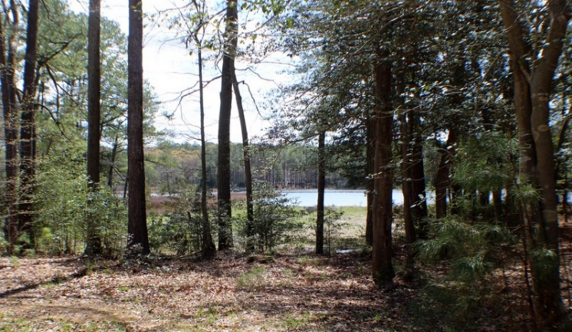

Extensive Plantings on 7.2 acre house lot:

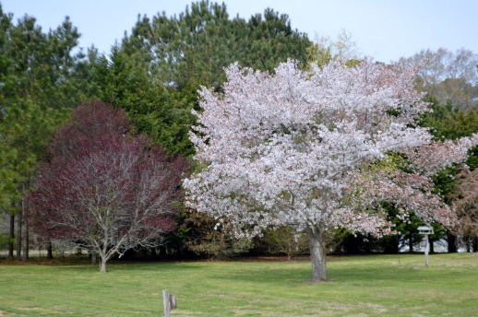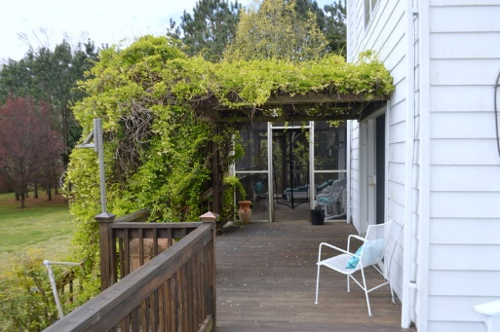

Here is a list of the owners of the many, many plantings:

Besides all the pines (yellow, white, blue spruce, bayberry)
knock out roses welcome visitors from the opening of the driveway
We have the magnificent Dawn Redwood by the garage/office.
2 weeping cherries, one very large and one very small.
3 Japanese cherries from the kitchen door to the other side of the office.
2 flowering cherries in the backyard.
2 flowering plums in the right corner of the backyard
3 lilac bushes
A lace leaf Japanese maple sits on the corner of the house on the kitchen side of the front of the house
Bradford pears line one side of the driveway from the field on back
The pine stand that we consider part of the yard has azaleas sprinkled throughout.
Azaleas, knockout roses, and oak-leaf hydrangeas fill the foundation plantings and flowerbeds.
Foundation plantings include a daisy gardenia by the kitchen steps,
Hydrangeas, privet, gardenia, nandina, camellia, jasmine
And some beautiful bushes that I can’t begin to name, all sprinkled with bulbs (iris, daffodils, star of Bethlehem, etc.) Plus ground plants (hosta, candy-tuff, parsley, lemon grass, etc.)

Of note is the Akibia vine which covers the pergola.
And the huge, short-needled evergreen tree that looks like it comes from Mordor and “almost has a voice of its own” that grows in the center of the circle driveway.
Oh, and the crepe myrtle, dogwoods, and the hardwoods (oak, maple, gum....).

Wildlife:

A pair of nesting eagles on the end of lot, not to mention the osprey.
Birds of every shore variety. Hummingbirds have just returned. Blue herons, egrets can be seen in the creek, cardinals, bluebirds, wood ducks, mallards, geese.
White-tail deer, Raccoons, Opossums, Muskrats, fox.

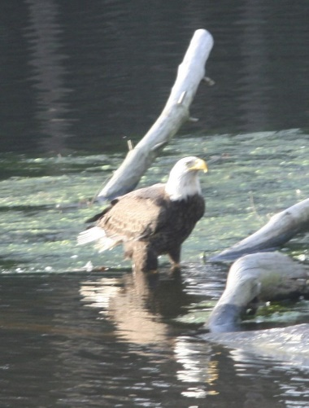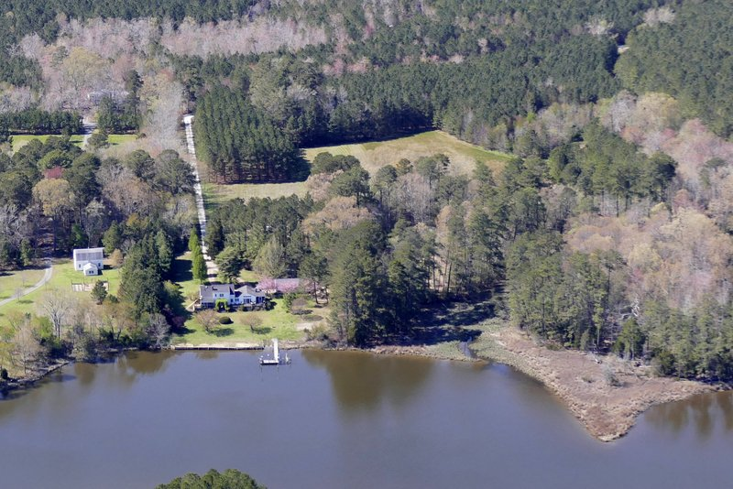

Lots of bang for buck here.
Come see 20 acres of wonderfully private waterfront.
And just nine minutes from Onancock.

